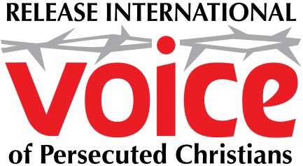

MARTYRS’ DAY CHURCH PRESENTATION NOTES

Introduction

These notes provide a suggested outline for you to speak at your church on Release International’s Day of the Christian Martyr commemoration. They should be used alongside the Martyrs’ Day PowerPoint presentation.

Outline

These summaries identify the ten PowerPoint screens and suggest what you might cover under each.

(1) Release International Logo – You might begin with an introduction about Release International. This might include:
- our origins in the life, suffering and witness of Richard Wurmbrand;
- that we are currently active in more than 25 countries around the world;
- that we seek to serve, support, resource and care for persecuted Christians, enabling them to survive – and to thrive – as servants of Christ.

(2) Martyrs’ Day Logo – You might then remind people that at this event we have a particular focus on martyrdom and martyrs.

(3) Definition of ‘Martyr’ – What is a ‘martyr’? The biblical word from which we get our English word originally had the meaning of “witness” – and is often translated that way in our New Testament, where it tends to refer to someone who was “a witness to the resurrection of Jesus Christ.” However, the prevalence of persecution (and persecution that led to death) meant that by the end of the first century the Christian usage of the word had evolved to refer to a Christian who witnessed to Christ by his or her death. This is the common meaning of the word as it has entered the English language.

(4) Picture of Nigerian Christians – Release International works through trusted Christian partners around the world to support persecuted Christians. This includes supporting and caring for the families of martyrs. One example would be in Nigeria, where Release supports biblically-based trauma counselling programmes. Most Christians who attend these workshops have lost loved ones. The course seeks to help them respond biblically and faithfully to the trauma they have suffered, even to the point – by the grace of God – of being able to forgive their persecutors.

(5) Bible reading – Our Martyrs’ Day pack includes a summary of how the Apostle Paul responded to the realities of persecution. It starts with the reminder that Paul was himself eventually martyred.
In what is probably his last letter (2 Timothy) he refers to the expectation that this will happen soon.

(6) Bible text (2 Timothy 4:6,7) – This screen refers to the verses mentioned in (5) above.

(7) Summary of Paul’s response to persecution – This screen summarises the four points you will find made in the Sermon Notes on page 4 of the brochure. The first bullet-point will appear when you initially click on this screen. The subsequent three bullet-points will appear on further clicks. You can use the material in the pack to speak to these four points.

(8) I will not abandon them – In the final section you will want to move, as always, to the application, in terms of how people might respond to the realities of persecution and martyrdom today. Release’s
I will not abandon them slogan sums up the challenge. You may then want to elaborate and specifically highlight how people can respond, prayerfully and practically.

(9) The Release magazine – You may want to emphasise the value of being informed and resourced to pray for persecuted Christians. Release’s free quarterly magazine has news from around the world, and comes with a prayer diary, giving you a brief prayer point for each day.

(10) Release logo – with contact details – The final Pscreen offers telephone, email and website details, enabling you to encourage people to consider making a gift or to give regularly, to support Release’s ministry to persecuted Christians around the world.

