Partner Profile:
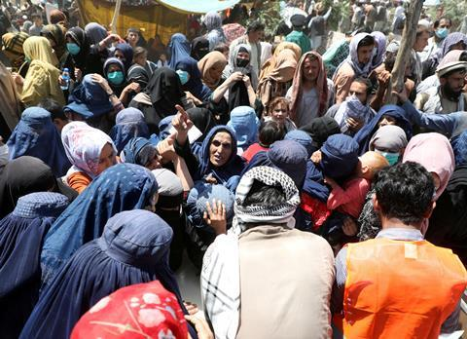
Operation Angel Afghanistan and North Pakistan
Release International partner, Operation Angel, provides critical ministry support to seekers and believers in Afghanistan and North Pakistan. Their broadcast media ministry enables radio programmes sharing the Gospel to reach rural areas. This is a vital lifeline in hard-to-reach locations, and it is estimated that they have over 200,000 listeners. They also provide a telephone helpline for Christians and seekers who need to talk and share their faith in safety. Around 900 Afghans called the helpline in 2020. They also provide telephone Bible classes to small groups.
Operation Angel ministers through partnerships with local ministries, to Afghan refugees in Europe who have fled. The Greek Island of Lesbos has thousands of Afghan refugees in camps and believers’ groups are growing. Operation Angel provides global outreach to Afghans online and holds other events and conferences including courses on Christian marriage, healthy family life and servanthood. In 2020 they ran a 5-day winter camp for Afghan believers in Finland. One of the team visited Afghanistan last year and told us: “I was invited to meet with an extended family, some who had recently come to faith. We had a great Bible study, and I stayed all day. I felt I could help the one brother who was becoming negative about other believers in the country. At the end one of them said, ‘It feels like you’re a member of our family!’”
With the recent events unfolding in Afghanistan and the return to power of the Taliban, this work is even more critical and needs your prayers. It will now be much more difficult and dangerous for believers and seekers in Afghanistan and North Pakistan to access any Biblical materials, so radio ministry is a key tool to enable the Word of God to be spread.
We need to continue to hold Operation Angel in our prayers as they continue support Afghans to grow in their faith in Jesus Christ and seek to follow Him. We pray that they will understand what it means to be a disciple of Jesus Christ and be transformed into his image.

